What is XAMPP?

XAMPP stands for cross-platform, Apache, MySQL, PHP and Perl. It’s a simple and lightweight solution that allows you to create a local web server for testing purposes. Since XAMPP is cross-platform, it also works on Mac and Linux, but today we’re going to focus on how to set up XAMPP on Windows 10.

Installing XAMPP

Go to the[Apache Friends website](https://www.apachefriends.org/index.html) and download XAMPP.

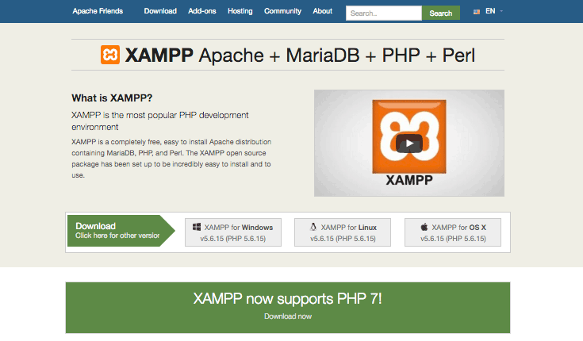

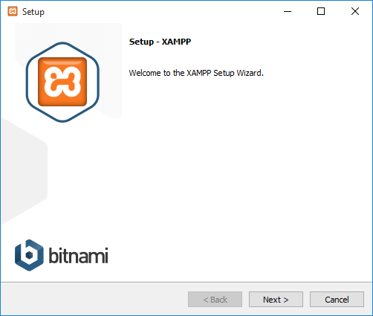

The XAMPP setup wizard.

In the next window you will be asked to select which components of the software you would like to install and which ones you don’t want. Some options, such as Apache and PHP are essential to running the software and will at automatically installed, so they are greyed out so you can’t select them.

It’s up to you which components you want to install. Since we want to run WordPress in our localhost environment, leave MySQL and phpMyAdmin checked and uncheck the remaining options.

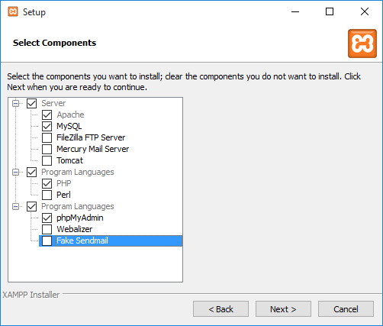Choose the options you want to install.

Next, select the folder where you would like to install XAMPP on your machine. I’m going to create a new folder in C:\Program Files\XAMPP.

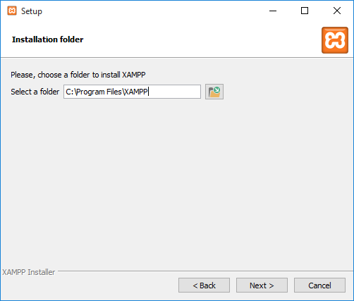Enter the path where you would like to install XAMPP.

In the next window, you’ll be asked whether you would like to install Bitnami for XAMPP, which offers free tools for installing WordPress, Drupal and Joomla! on top of XAMPP.

Since we’re going to install WordPress manually later in this turorial and don’t need free installers, untick “Learn more about Bitnami for XAMPP” and click Next.

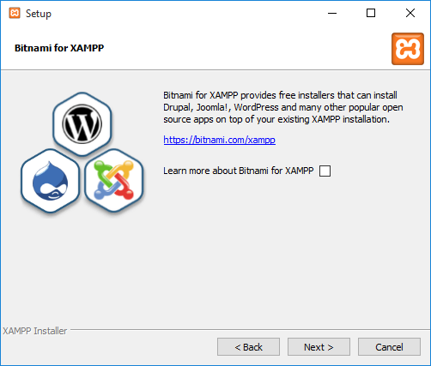We don’t want to install any free installers.

After going through all those initial installation steps, XAMPP is now finally ready to install. Click Next.

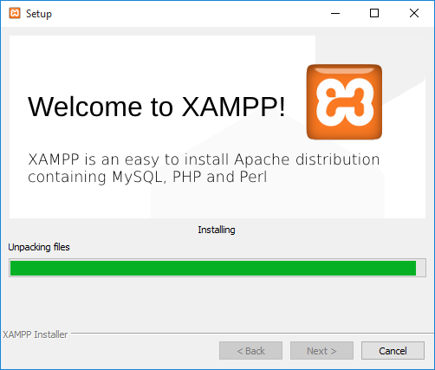Almost there…

Once installed, you’ll be asked whether you would like to start the XAMPP Control Panel, which provides an interface for running your localhost environment. Leave this option ticked and click Finish.

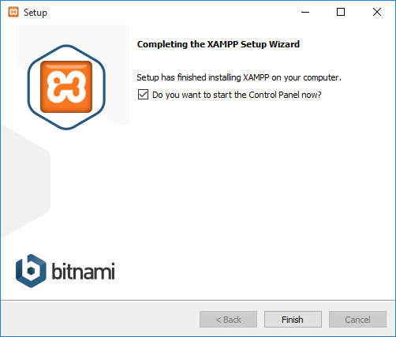The installation process is quick and painless, though it’s not uncommon for Windows to throw up warnings every now and then.

The Control Panel will automatically open, but if you unchecked the option in the prevous window, you can go to the XAMPP folder on you computer and openXAMPP Control Panel instead.

If the installation process went well and everything is running smoothly, the control panel will open with black and blue text updates at the bottom. But if there are issues…

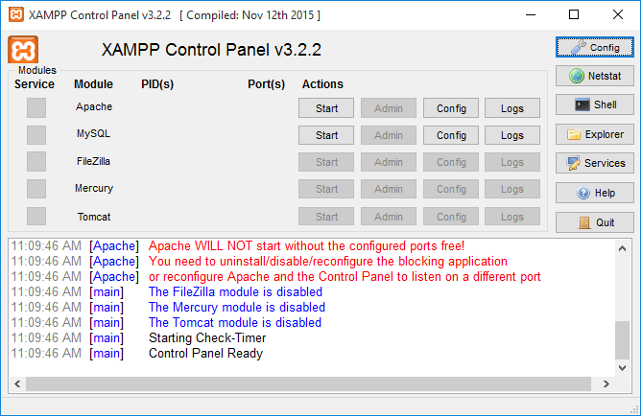Gah! Errors!

… Well, look at that – red text! It looks like I’ve run into some errors already. Not to fear, it looks like a port conflict.

Fixing Port Errors

The main reason why XAMPP throws up errors like this is due to another program on your machine using ports 80 or 443 – the ports Apache and MySQL need in order to run.

If you’re using Windows 10, World Wide Web Publishing Service is most likely using post 80. This program, which is for Internet Information Services (IIS) for Windows® Server, comes pre-installed and if you’re not using it, you can simply stop the service running on your machine or even delete it.

To stop the service running, do the following:

1. Go to Start, type in “services.msc” and select the best match
2. Scroll down in the Services window to find World Wide Web Publishing Service
3. Right click on it and select Stop
4. This should free up port 80. When you restart XAMPP it should run without errors

If that doesn’t resolve the issue, you can set up a new firewall rule to forceably unblock the ports:

1. Open Windows Firewall on your machine and > click on Advanced Settings on the left
2. Click on Inbound on the left then on the far right click New Rule
3. Click Port and then TCP. In the field below for Specific Ports type in “80, 443” and clickNext
4. Check Allow the Connection then click Next
5. Make sure all options are checked and click Next
6. In the name field, enter whatever you want, but for the sake of consistency let’s type inLOCALHOST1. Click Finish
7. Now repeat steps 1-6, but name this new rule LOCALHOST2 and click Finish
8. Restart your computer

Ports 80 and 443 should now be open locally on your computer.

I should also mention at this stage that if you get any security/firewall warnings while installing or using XAMPP (such as the prompt pictured below), make sure you check “Private networks, such as my home or work network” and click “Allow access.” This is very important. If you don’t allow access, XAMPP won’t work.

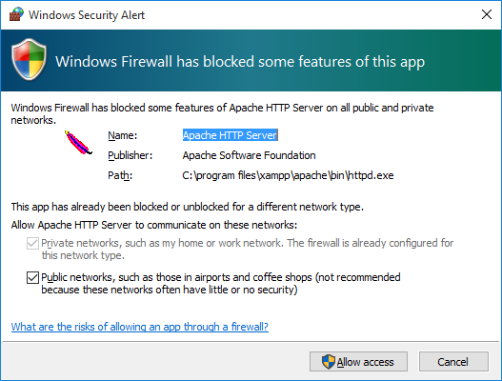You need to allow access so XAMPP can work.

Running XAMPP

Now, let’s see if everything works smoothly.

If you previously quit the control panel to fix a port issue, restart XAMPP. Then start up both Apache and MySQL.

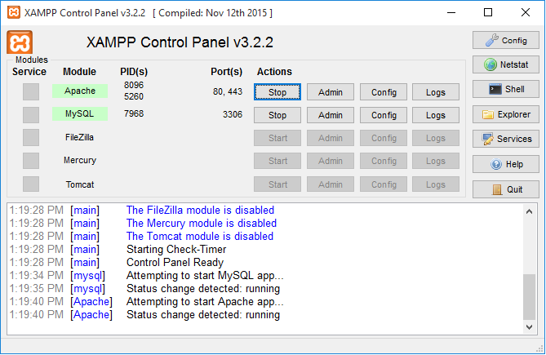You have no idea how happy I am to see both Apache and MySQL working, or maybe you do!

Both services are running fine. Excellent!

Bottom of Form

You can check if your new local server is installed by visiting http://localhost in your browser.

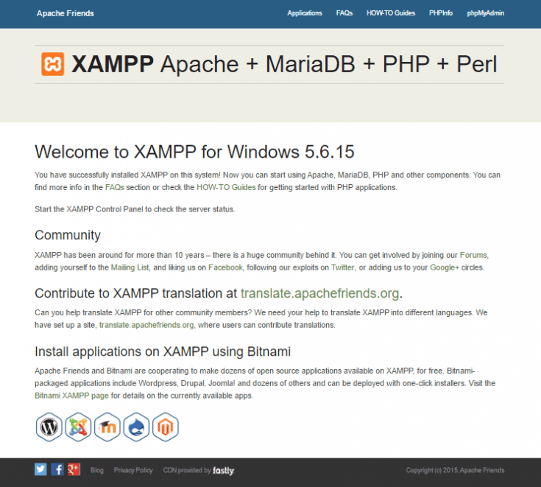Woohoo! Successfully set up.

Setting Up Your MySQL Database

Before we install WordPress, we need a database.

In your XAMPP Control Panel, click the Admin button in the MySQL section.

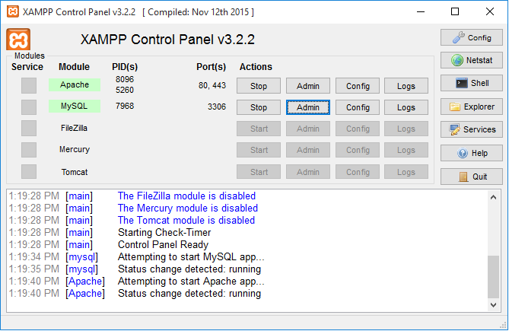Click “Admin” to set up MySQL.

A new browser window will automatically open with the phpMyAdmin interface.

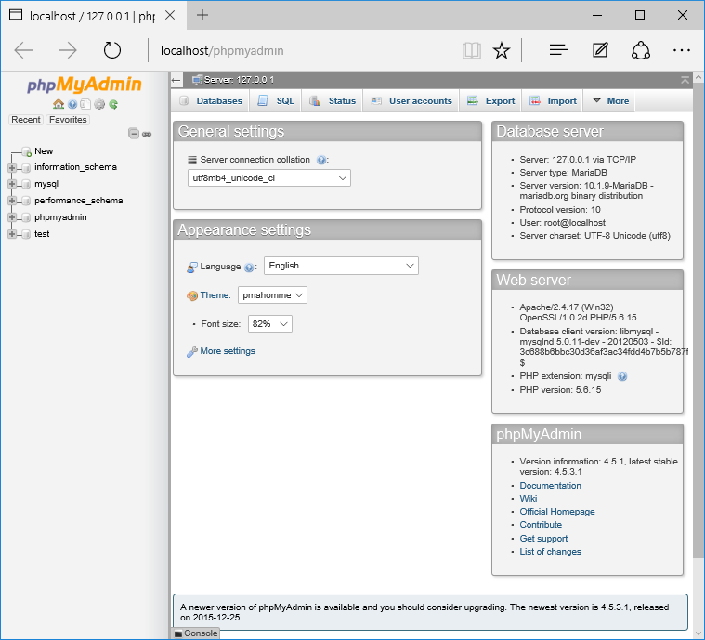Click “Admin” to set up MySQL or go to “localhost/phpmyadmin” in your browser.

Click on Databases near the top-left and you’ll be prompted to create a new database. I’ve called mine “WP.”

When you’ve entered a name, click Create and close the window.

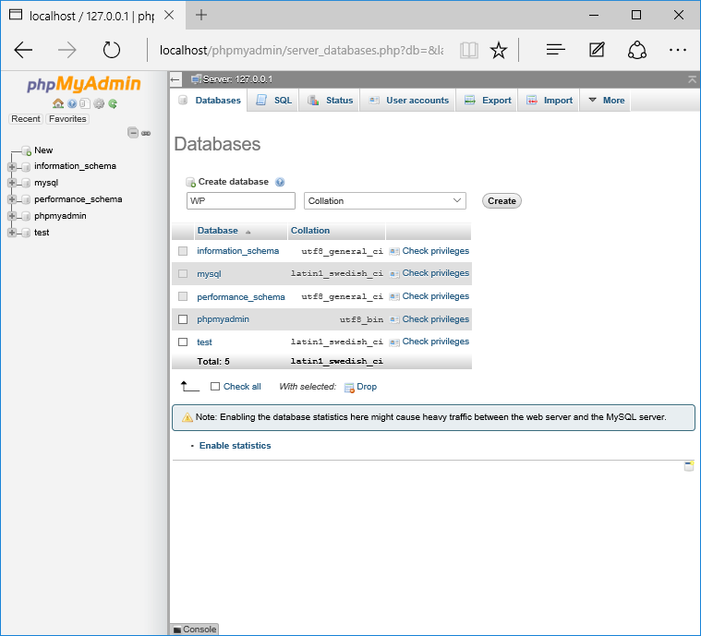Quickly and easily set up a new MySQL database for WordPress.

Download and Install WordPress

[Download](https://wordpress.org/download/) the latest version of WordPress.

In order to get WordPress working with XAMPP we need to unzip WordPress in the right folder. Go to the XAMPP folder on your computer and open the htdocs folder – C:/Program Files/XAMPP/htdocs.

Unzip WordPress into its own folder and rename it whatever you like. For consistency, I’m going to call this installation of WordPress “WP” to match the name of the database I just created.

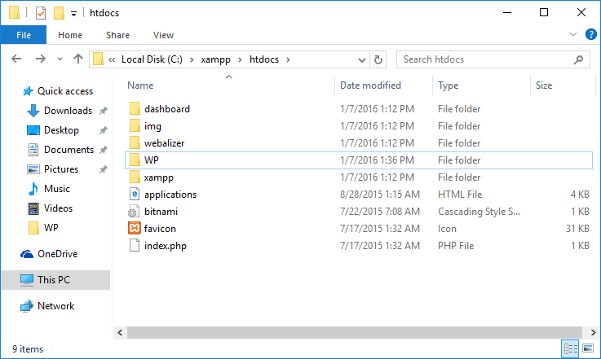My installation of WordPress is called “WP.”

Open the WP folder where you saved WordPress, find the*wp-config-sample.php* file and rename it *wp-config.php*. Open the file and scroll down until you see the following lines:

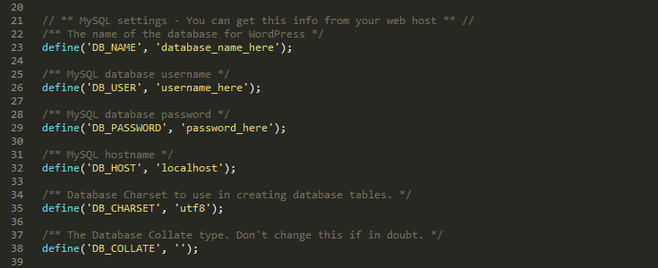Update your wp-config.php file with your database details.

These lines of code define the login details for your database:

* Replace*“database_name_here”* with the name of your database, which in my case is “WP”
* Replace*“username_here”* with *“root”*and leave *“password_here”*blank
* Save the file and close it

Now we can get on with actually installing WordPress.

Open your browser and go to http://localhost/wp/

You should see the translation screen that comes before the famous five minute WordPress installation process.

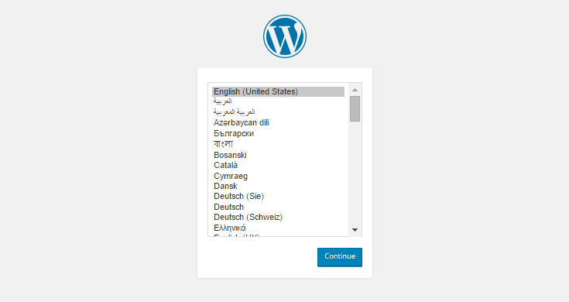Choose the language you want to use WordPress in.

Once you’ve chosen your language, continue onto the next screen and enter you username and password details. Click Install WordPress.

Your WordPress installation is now complete!

Setting up WordPress Multisite

Having Multisite setup locally provides an efficient way to test themes and plugins in a Multisite environment, but also makes it a quick and easy to have multiple instances of Multisite set up.

Open your *wp-config.php* file again and add/edit the following lines to activate Multisite’s installation mode:

|  |  |
| --- | --- |
|  |  |
|  | define('WP_DEBUG', false); |
|  |  |
|  | define('WP_ALLOW_MULTISITE', true); |
|  |  |
|  | /* That's all, stop editing! Happy blogging. */ |

[**view raw**](https://gist.github.com/raewrites/370cc1633defed3b6cb7/raw/e7d14df2a1952cf5145213f2d1c20cc6d112b590/enable-multisite)[**enable-multisite**](https://gist.github.com/raewrites/370cc1633defed3b6cb7#file-enable-multisite) hosted with  by **[GitHub](https://github.com/)**

Open XAMPP and ensure Apache and MySQL are running.

Login to your localhost site in your browser and under Tools you will now have a new option, Network Setup.

Enter a name for your network and your email address, then click “Install.”

WordPress will prompt you to edit your *wp-config.php* and *.htaccess* files.

Following the onscreen instructions, open *wp-config.php* and add the following lines underneath your previous edit:

|  |  |
| --- | --- |
|  | define('WP_DEBUG', false); |
|  |  |
|  | define('WP_ALLOW_MULTISITE', true); |
|  |  |
|  | define('MULTISITE', true); |
|  | define('SUBDOMAIN_INSTALL', false); |
|  | define('DOMAIN_CURRENT_SITE', 'localhost'); |
|  | define('PATH_CURRENT_SITE', '/'); |
|  | define('SITE_ID_CURRENT_SITE', 1); |
|  | define('BLOG_ID_CURRENT_SITE', 1); |
|  |  |
|  | /* That's all, stop editing! Happy blogging. */ |

[**view raw**](https://gist.github.com/raewrites/5122a9c17ff06580a1b5/raw/b821d3b8d7b74033ee73f7543c39b611feb7675e/setting-up-multisite)[**setting-up-multisite**](https://gist.github.com/raewrites/5122a9c17ff06580a1b5#file-setting-up-multisite) hosted with  by **[GitHub](https://github.com/)**

Next, open *.htaccess.* If you can’t find it, make sure hidden files are displaying on your computer. If you do not have a*.htaccess* file already, then create it in the same directory as your wp-config.php file. If you do have a *.htaccess* file, replace any existing lines with these new ones:

|  |  |
| --- | --- |
|  | # BEGIN WordPress |
|  | RewriteEngine On |
|  | RewriteBase / |
|  | RewriteRule ^index\.php$ - [L] |
|  |  |
|  | # add a trailing slash to /wp-admin |
|  | RewriteRule ^([_0-9a-zA-Z-]+/)?wp-admin$ $1wp-admin/ [R=301,L] |
|  |  |
|  | RewriteCond %{REQUEST_FILENAME} -f [OR] |
|  | RewriteCond %{REQUEST_FILENAME} -d |
|  | RewriteRule ^ - [L] |
|  | RewriteRule ^([_0-9a-zA-Z-]+/)?(wp-(content|admin|includes).*) $2 [L] |
|  | RewriteRule ^([_0-9a-zA-Z-]+/)?(.*\.php)$ $2 [L] |
|  | RewriteRule . index.php [L] |
|  |  |
|  | # END WordPress |

[**view raw**](https://gist.github.com/raewrites/0a3b4822abbbe49b0f84/raw/e061875faf52c145c58e61a95065704564d18480/multisite-htaccess)[**multisite-htaccess**](https://gist.github.com/raewrites/0a3b4822abbbe49b0f84#file-multisite-htaccess) hosted with  by **[GitHub](https://github.com/)**

Multisite should now be installed.

You’ll need to log in again, and when you do you’ll see the WordPress dashboard from where you’ll be able to access individual sites in your network.

# How to Install WordPress on Localhost Using Xampp Server

**Posted by**[**WPDean**](http://wpdean.com/)[**4 Comments**](http://wpdean.com/install-wordpress-on-localhost-using-xampp/#comments)

This Tutorial is a Part of Post Series:

1. ~~How to Install WordPress on Localhost using XAMPP?~~
2. [**How To Move WordPress From Localhost To Live Host Server?**](http://wpdean.com/how-to-move-wordpress-from-localhost-to-live-host-server/)

If you are a complete beginner to WordPress, you might not know that it is possible to install WordPress locally in your computer. You can create fully functional WordPress sites in your computer and test the site without any internet connection.

There are numerous advantages of setting up a local server (localhost) and installing WordPress on localhost. If you are a [**theme/plugin developer**](http://wpdean.com/services/) or need to test different themes and plugins on a regular basis, installing WordPress on localhost could be a very effective solution for you.

The WordPress site you create in localhost will load almost instantly. As the site is not connected to the internet, you can rest assured about its security. Some WordPress developers like to develop the site in localhost first and then move it to a live server.

In today’s post, I will show you how to **install WordPress on localhost using XAMPP server**.

### What is XAMPP?

The full elaboration of XAMPP is cross-platform, Apache, MySQL, PHP and Perl. This simple and convenient solution lets you create local web servers on your computer. XAMPP works perfectly on Windows, Linux, and Mac.

XAMPP comes with two components that are essential for installing WordPress – Apache and MySQL. Apache is used to create the local server. And MySQL lets you create the database for your WordPress site.

## Installing XAMPP Server on Localhost

To install XAMPP on localhost, Download it first from the [**Apache Friends website**](https://www.apachefriends.org/download.html). There are separate download links for Windows, Linux and OS X. There is no 64-bit version for Windows. But the 32-bit version works perfectly for the 64- bit too. I have used and tested it personally.

Download the installer file. Once the download finishes, click the downloaded file. Depending on your operating system, you might need to allow the software to be installed.

While you should be cautious about installing unknown applications, you can safely install XAMPP. Allowing it to install will take you to the setup wizard. Click ‘Next’.

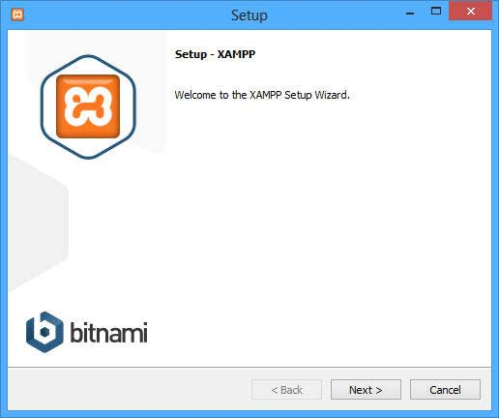

The next window lets you customize which components you want to install. Options like Apache and PHP are required. Therefore, you can’t deselect them. But you can uncheck the other options. For installing WordPress, the necessary components are Apache, MySQL, PHP, and phpMyAdmin. Once you have selected these, click ‘Next’.

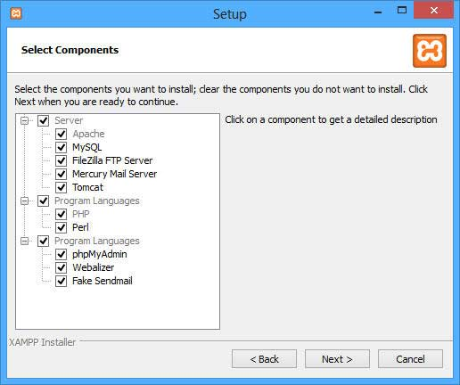

In the next page, you will be asked to select the folder where you want to install XAMPP. Click the folder icon to open the file browser and to select a custom folder. After making the choice, click ‘Next’.

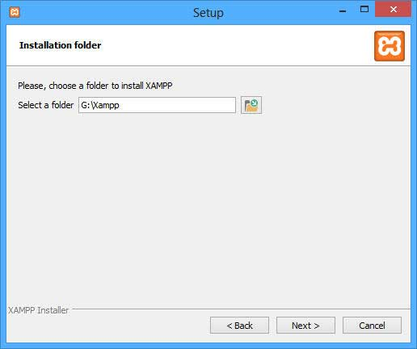

In the next screen, you will be asked to install Bitnami for XAMPP. Bitnami makes it simpler to install third-party CMS like WordPress, Joomla and Drupal in XAMPP.

Since we will be [**installing WordPress manually**](http://wpdean.com/how-to-install-wordpress-manually-step-by-step-tutorial/), we won’t need this option. Therefore, you can simply uncheck the box and click ‘Next’.

Now, XAMPP is ready to be installed. Click ‘Next’ to start the installation process. It will take some time to finish installing.

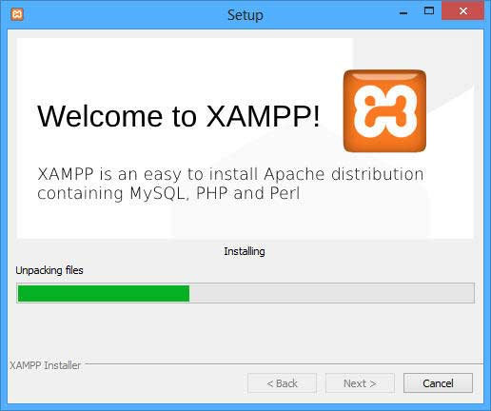

While installing XAMPP, if your computer provides a security notice like the following, uncheck the ‘Public networks …’ box and check the ‘Private networks…’ box and click ‘Allow access’. This will create a rule for XAMPP in your security system.

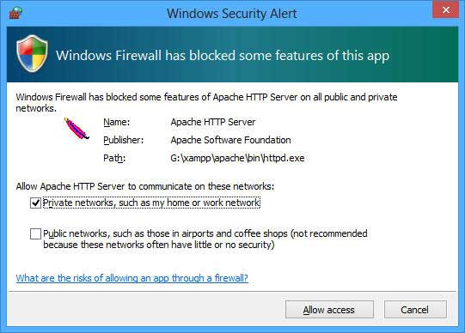

In the final installation window, you will find a checkbox to start the XAMPP control panel. Leave it checked and click ‘Finish’.

At this point, the control panel will be started. You can also open the control panel from your programs list or from the directory where you installed it. The control panel will look like this –

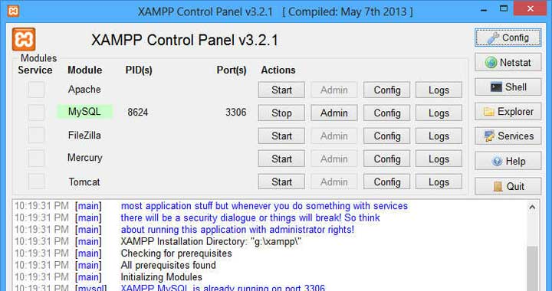

Before using XAMPP, make sure that you don’t have any other application running that also uses the same ports. Skype is a common example in this regard. Quit any such application and restart XAMPP.

In the XAMPP control panel, you will find different components listed – Apache, MySQL, FileZilla, Mercury, Tomcat etc. All of them have separate start/stop, Admin, Config and Logs buttons. Fire up Apache and MySQL by clicking the respective Start buttons. If they have started successfully, you will notice a light green background behind the component names.

If both Apache and MySQL are running successfully, you can congratulate yourself. You have successfully installed XAMPP server in your computer. To test your local server, open your favorite browser and enter the following URL – **http://localhost/**

The page should look like the following –

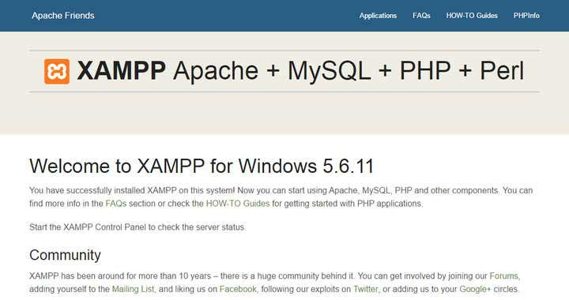

### Creating a Database

Now that you have installed XAMPP let’s see how to install WordPress. First of all, you have to create a database to install WordPress. To do that, get back to the XAMPP control panel. Click on the ‘Admin’ link of the MySQL section. This will take you to the **phpMyAdmin** page.

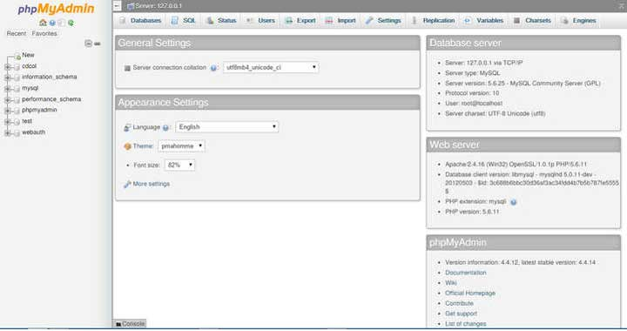

You can also get to this page by entering the following URL into your browser –

**http://localhost/phpmyadmin/**

There is a menu on top of the page. Click the ‘Databases’ link. This will bring a page like the following –

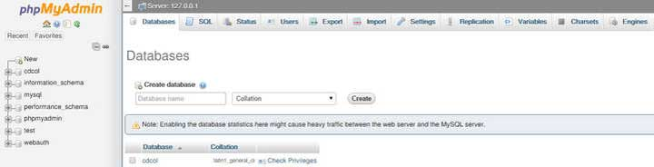

Right under the big ‘Databases’ title, you will find a section titled ‘Create database’. Provide the database name and click ‘Create’. This will create the database for you. Note down the database name, we will need it for installing WordPress.

## Installing WordPress on XAMPP

Now, to install WordPress on XAMPP, Download the latest version of WordPress from the [**official site**](https://wordpress.org/download/). Extract the zipped archive to your desktop. Open the folder where you have installed XAMPP. Locate the folder titled ‘htdocs’. Copy the extracted WordPress folder into the htdocs folder. If you haven’t changed the default installation settings, the htdocs folder should be located at the following address –

**C:/Program Files/XAMPP/htdocs**

In your browser, open the following URL – **http://localhost/wordpress/**

In the resulting screen, you will be asked to select the language. Choose your preferred language and click ‘Continue’.

In the next screen, you will be told that some information is needed for installing WordPress. These are the things we will need –

1. Database Name
2. Database Username
3. Database Password
4. Database Host

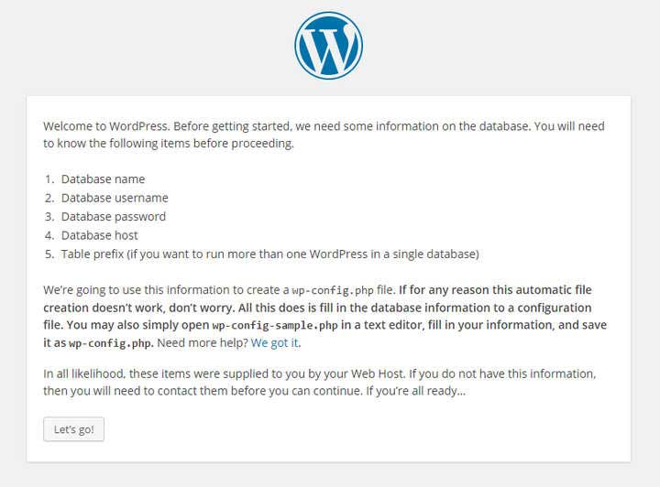

You might not know all the information. Don’t worry, I will provide you with the necessary information. Click the ‘Let’s go!’ button at the bottom.

At this point, you should be on this page –

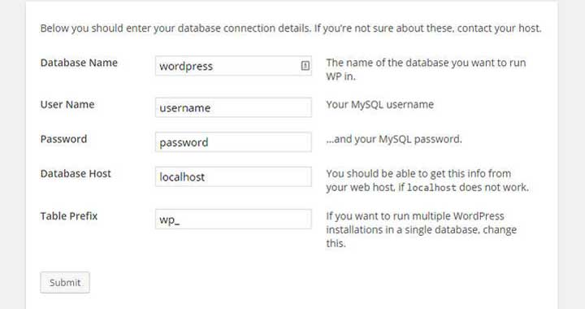

Provide the following information in the boxes –

* Database Name: Write the name of the database you created a while back.
* User Name: root
* Password: Don’t put anything in this field. Clear any default text and leave it empty.
* Database Host: localhost
* Table Prefix: wp_

Once you have provided the necessary information, click ‘Submit’. In the next page, click the ‘Run the install’ button. You will be taken to a page like the following –

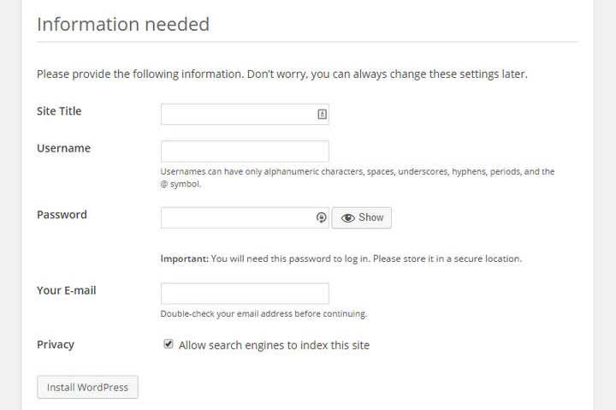

In the ‘Site Title’ field, provide the title of your test site. Then, the ‘Username’ and ‘Password’ fields will let you create an admin account for your site. As you will need this information to log into your website, save or memorize these.

In the ‘Your E-mail’ field, provide an email address. Lastly, the ‘Privacy’ could be used to hide the site from search engines. After making the necessary changes, click ‘**Install WordPress**‘. If everything is okay, you will be provided with a success page. Click the ‘Log In’ button at the bottom.

This will take you to the login page of your website. Provide the username and password you just provided and click ‘Log In’. If they are correct, you will be taken to the admin dashboard of your WordPress site.

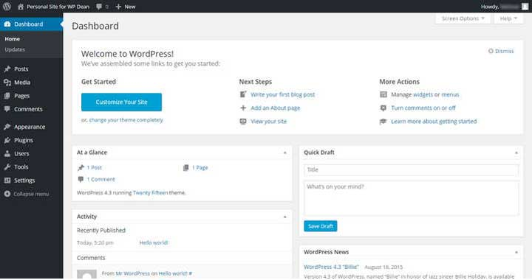

If you can view the dashboard, then WordPress is successfully installed.

### What to Do Now?

Now that you have installed WordPress on XAMPP locally, you can start exploring the available options.

You can [**install new themes**](http://wpdean.com/3-different-ways-to-install-a-wordpress-theme/), plugins, publish new posts, pages, etc.

A WordPress site in localhost and a WordPress site on the live server are exactly the same, except the difference in their locations. We wrote a detailed post about [**exploring the WordPress dashboard**](http://wpdean.com/wordpress-dashboard-few-basics/) a while back, feel free to check it out.

It is possible to create a fully functional website in your localhost. And then, you can move the site from localhost to your hosting. Check out [**this in-depth guide**](http://wpdean.com/how-to-move-wordpress-from-localhost-to-live-host-server/) to know how to move a WordPress site from localhost to a live server.